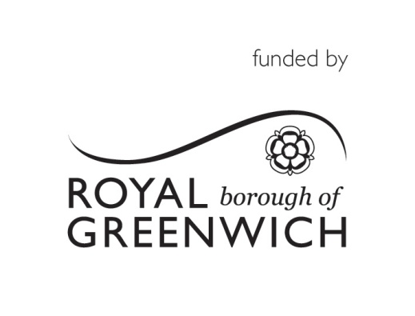 Community Cohesion Small Grants Fund
Project Proposal Form
Please fill in the project proposal form below and then send it to abbey.sode@royalgreenwich.gov.uk by 21st June 2019.
You may wish to discuss the outline of your project with RBG Commissioning Officer for some initial feedback before submitting your proposal:
Commissioning Officer: 020 8291 6477 or email abbey.sode@royalgreenwich.gov.uk
Before completing this form please read the Funding Proposal Form Guidance Notes.
The purpose of the grant will be:
- Support peer mentoring, inclusive activities, innovation and development across small organisations.
- Applications aiming to reduce social isolation and/or promote digital inclusion will be prioritised, as well those from faith groups and BAME group.
- Priority considered for organisations not already receiving any funding from other direct sources.
- Maximum grant amount per application is £3,000

About your group
Name of your Group:
Main contact:
Position in group:
Address:
City:
County:
Postal code:
Email address of main contact:
Main telephone number:
Ward:
Are you a charity
If no, do you have a constitution
Does your Organisation have a bank account
If no, which organisation will hold these grant funds if your application is successful

About the project
Project Title Give your project a short title so it can be easily identified (Max 10 words)
Project Summary. Please describe your project and what is seeks to achieve (Aims of the project) (No more than 200 words):
Which Priority does this project address?
Support peer mentoring, inclusive activities, innovation and development across small organisations
Reducing social isolation
Supporting individuals with specific disabilities e.g. autism, spina bifida etc
Adopting digital inclusion, innovation and development.
Supporting new and emerging communities to access services
What is the focus of your project in terms of isolation? (Please tick all that applies).

Culture and recreation (e.g. art, sport, music, history)
Community cohesion and engagement
Social activities (e.g. fun days, bingo, lunch clubs)
Health, wellbeing and personal and social development
Unemployment
Financial hardship
Training and education
Community safety (e.g. crime, anti social behaviour, safety initiatives)
Other (please specify)

How will you go about delivering your project? (Please tick all that applies).

Providing workshops or training and development programmes
Running events and activities
Holding meetings, clubs or support groups
Providing trips and away days
Hiring a venue
Purchasing equipment or services
Other (please specify)

Who are the main beneficiaries? (Please tick all that applies).

Older people
Minority ethnic groups
Low income groups
People with various disabilities
People with mental health problems
People with a specific disabilities (please specify) Diabetes, back pain, sciatica.
People with learning disabilities
The whole community
Other (please specify)

What is the location of the project (where will it take place)?

What is the start date for the project and when will it be completed?
Is the timetable for the delivery for this realistic?
Start date: | End date (must be before March 2020):

The Local Community
How many people will be involved in organising and running the project?

What will their role be? (Please tick all that applies).

Development roles (e.g. coaching and training)
Manual roles (e.g. gardening, clean-ups, maintenance)
Marketing and promotion
Coordination and planning (e.g. event organising)
Creative roles (e.g. script writing, performing, directing)
Fundraising
Social support, advocacy and advice (e.g. befriending)
Other (please specify)

Which of these Outcomes will your Project contribute towards? (Please tick all that applies).

People have an increased sense of self-worth
Reduced experience of inequality
Adults with disabilities and other vulnerable adults are more independent
Adults with disabilities and other vulnerable adults have increased physical and mental well-being
More adults with disabilities and other vulnerable adults are full and equal members of and contributors to society
Fewer adults with disabilities and other vulnerable adults are socially isolated or excluded.

What is your organisation contributing to the project?
Please give us details on what you will contribute (volunteer hours, gifts in kind, cash donations, other in-kind value: e.g. Value of other items or resources given for free)

Room or venue hire
Training and development
Staff, workers or volunteers
Equipment e.g. computers, sports kit, gardening tools
Providing management at no cost
Marketing and publicity materials
Other (please specify)

Project Budget
Total Project Budget | £
How much are you applying for? | £
Breakdown by cost Activity:
Item |  | Cost £
TOTALS: |  | £

How does your project represent good value for money?
Monitoring:
How will you provide us with information to show the numbers and types of people who have benefitted from the project and how they feel they have benefitted?
Data taken from sign-up sheets/attendance lists
Data/information taken from surveys/interviews
Before and after case studies
Photos/video
Other (please specify)

Please send your completed application form to: Abbey.sode@royalgreenwich.gov.uk by 5pm, 21st June 2019

