**NEW SPAM FILTER FOR EMAILS**

From Monday 1 June 2020 there will be a new email security tool and this document is to help you get the most out of it.

The biggest change is the ‘Report Message’ add-in, that works with Outlook 365 to allow you to report suspicious messages to Microsoft (our email provider - so they can improve detection). It also lets you manage how your Office 365 email account handles these messages.

How it works

Messages that the email system thinks are ‘spam’ or similar are automatically moved to a folder called ‘Junk Email’. It may not be accurate 100% of the time but it is very effective, and you can train it to work even better for you.

If you receive any junk email in your inbox, you can use the Report Message tool to send the message to Microsoft, which will then improve your spam filters. Just as usefully, if you find an email in your Junk Email folder that's not spam, you can use the Report Message tool to mark it as a legitimate email and move the message to your Inbox.

You can then report the incorrect filter to help Microsoft improve the spam filter. This reporting is how the system learns what are valid messages and what is spam. It is important to regularly check your Junk folder, to make sure you’re not missing any emails that you do want receive.

Stay vigilant

Please remain vigilant with any email whether it’s unsolicited or from someone you know, that doesn’t seem quite right to you.

* Look closely. The first part of the email address may look right, but the last part after the @ might not be correct.
* Carefully check links before you click by hovering over the link to ensure the destination is what you expect.
* Be especially wary of emails stressing urgency for action, even when you may know the sender (their account may have been compromised).
* Misspellings, incorrect grammar and odd phrasing can help to identify a message as fake.
* Always verify changes with a phone call, especially payment details or last-minute changes to invoices.

If you are still unsure or have already clicked the links or attachments in a suspect email, please contact the ICT Service Desk on 0208 921 8600 or email ict.servicedesk@royalgreenwich.gov.uk or your dedicated ICT Business Relationship Officer (see corporate intranet for details).

The Report Message tool

The report message tool will appear on your main toolbar in Outlook automatically. All the options for the Report Message tool can be accessed by clicking the button (which looks like the below image).

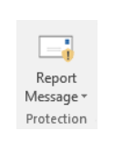

What you will see when you report a message

If you choose the Report Message button you will see several different options.

∙ Junk

∙ Phishing

∙ Not Junk

∙ Options

If you choose Junk, Phishing, or Not Junk, you will have the option to send a copy of the message to Microsoft, along with your classification of the message. This is optional. It is safe to do this, as the actual message is not sent, just details about the message will be i.e. who the sender is.

Classifications

**Junk email**:

Junk email messages are typically referred to as spam. These are messages that you do not want to receive that may be advertising products you do not use or find offensive. If you choose the Junk option, a copy of the message may be sent to Microsoft to help update our spam filters, and the message will be moved from your Inbox to your Junk Email folder.

**Phishing**:

Phishing is the practice of luring you into disclosing personal information, such as bank account numbers and passwords. Often phishing messages look legitimate but have deceptive links that actually open fake websites. If you select Phishing, a copy of your message may be sent to Microsoft to help update our filters, and the message will be moved from your Inbox to your Junk Email folder.

**Not Junk (legitimate email)**:

If you know the sender and you are expecting the message, or if you receive a message that is mistakenly marked as junk, you can use the Report Message tool to mark the message as Not Junk. This will move the message from the Junk Email folder back to your Inbox.

**Report Message tool options**:

Choosing Options from the Report Message button allows you to choose whether messages are automatically sent to Microsoft when they are reported as junk or phishing attempts.

**Change your Report Message options**:

Choose Options from the Report Message button

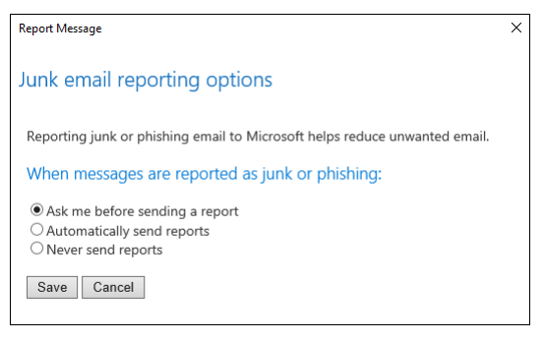

Once you have made your selection, choose Save. You will see the following message in the InfoBar in the message header confirming your changes were saved successfully:



Options settings are saved with the message, so in order to see your updated settings, you will need to select a new message first.