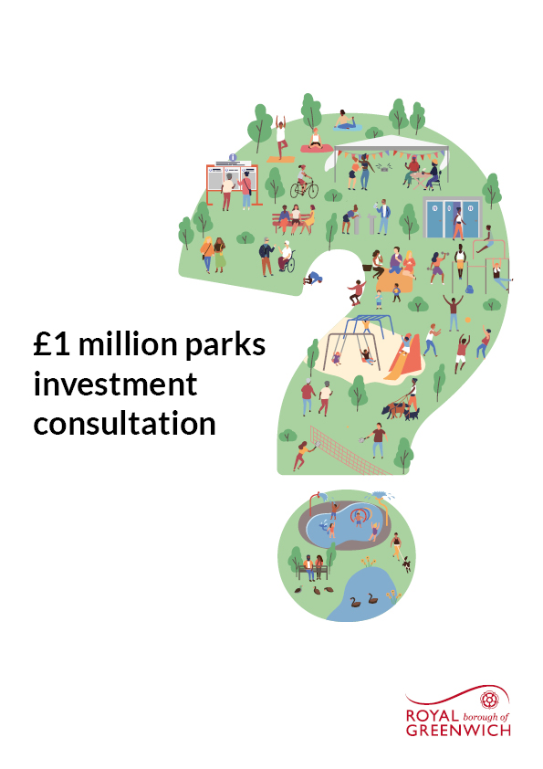

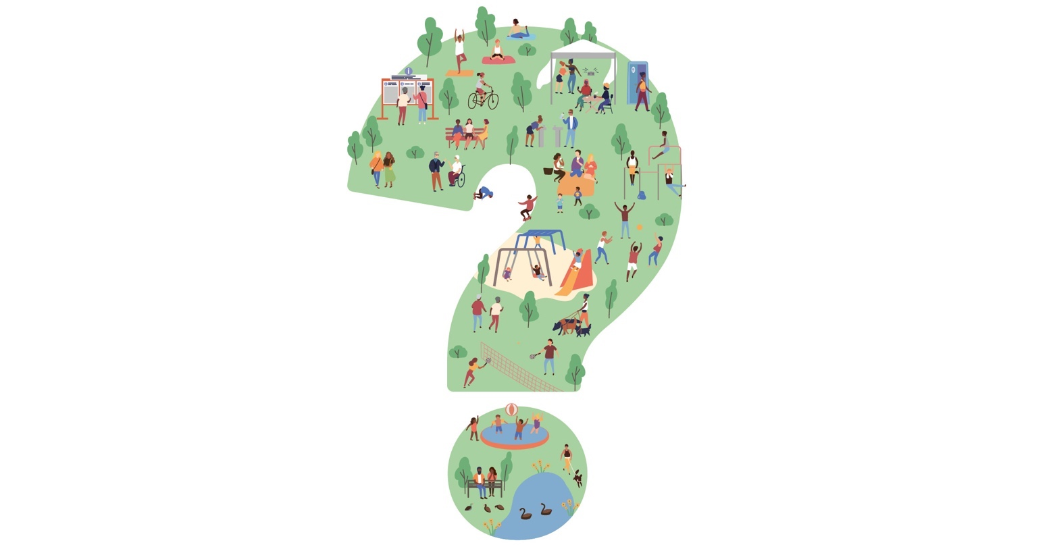

Tell us how we can improve the borough's parks!
'Parks have become even more important to us recently as one of the only places we could relax, exercise and meet with friends and family during the pandemic. To make sure our green spaces are the best they can be the Council is about to spend £1 million on improvements.
But what should we do? Create splash parks for kids, wildlife areas for nature or fabulous flower gardens - maybe a bit of all three or something completely different?
Tell us what you think by completing our short survey.'
Cllr Adel Khaireh, Cabinet Member for Culture, Communities and Equalities

What do you think about our parks?
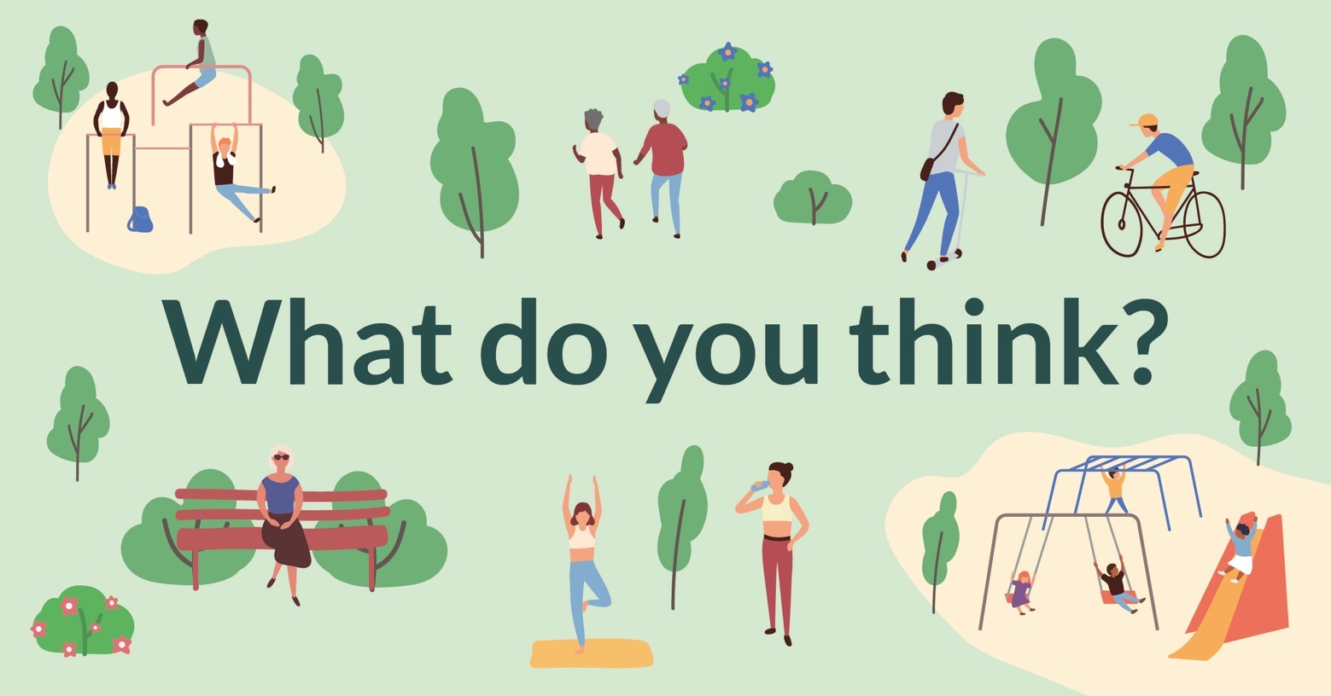

1: How valuable do you think our parks and open spaces are to the community?
1 Very valuable, 2 Valuable, 3 Neither valuable nor unvaluable, 4 Unvaluable, 5 Very unvaluable

Please tick one option only

❒ | ❒ | ❒ | ❒ | ❒
1 | 2 | 3 | 4 | 5

2: How satisfied are you with the condition of the borough's parks and open spaces
1 Very satisfied, 2 Satisfied, 3 Neither satisfied nor unsatisfied, 4 Unsatisfied, 5 Very unsatisfied

Please tick one option only

❒ | ❒ | ❒ | ❒ | ❒
1 | 2 | 3 | 4 | 5
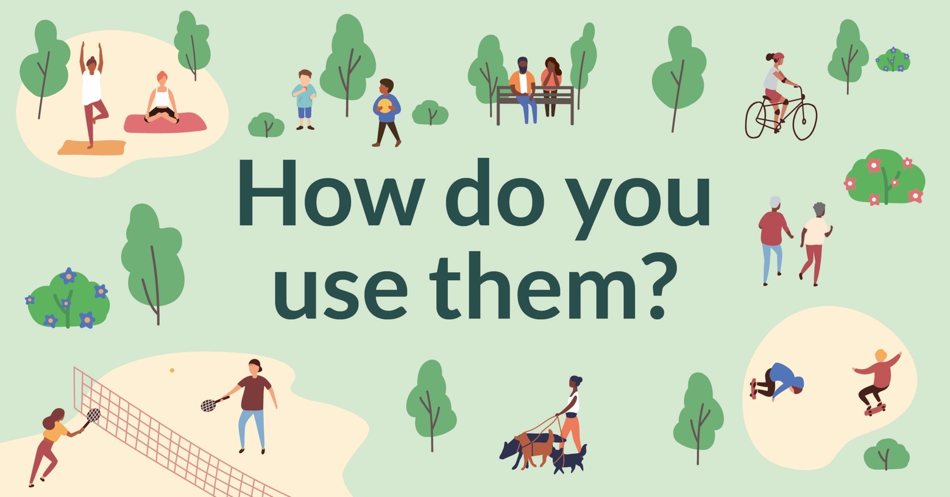

3: If members of the group like to visit parks, which parks to they go to and why do they like going there?

4: If members of the group don’t like to visit parks, why is that?

Your park priorities

5: As a group – what are the most important aspects of the park?

Please tick the ones they think are important

Play areas | ❒
Sport and fitness | ❒
Basic facilities and maintenance | ❒
Removal of redundant or damaged features/facilities | ❒
Heritage | ❒
Nature and wildlife | ❒
Events | ❒

6: In the warmer months, how often do members of the group go to the park?

Please tick all that apply:

❒ | Every day | ❒ | More than once a week
❒ | Once a week | ❒ | 2-3 times a month
❒ | Once a month | ❒ | Less than once a month
❒ | Never

If you answered "Every day", "More than once a week", "Once a week" or "2-3 times a month" to question 6 then go to question 8

If you answered "Once a month", "Less than once a month" or "Never" to question 6 then go to question 7

7: If any members have said that in the warmer months you visit the park once a month, less than once a month or never, please let us know why

8: In the cooler months, how often do members go to the park?

Please tick all that apply

❒ | Every day | ❒ | More than once a week
❒ | Once a week | ❒ | 2-3 times a month
❒ | Once a month | ❒ | Less than once a month
❒ | Never

If you answered "Every day", "More than once a week", "Once a week" or "2-3 times a month" to question 8 then go to question 10

If you answered "Once a month", "Less than once a month" or "Never" to question 8 then go to question 9

9: If any members have said that in the cooler months you visit the park once a month, less than once a month or never, please let us know why

10: How do members of the group get to the parks they visit?

Please tick all that apply

❒ | ❒ | ❒ | ❒ | ❒
Walk | Cycle | Public transport | Car | Other
10.1: If you selected other, please specify

11: Do the majority of group members mostly visit their park during the weekdays or weekends?

Please tick all that apply

❒ | ❒
Weekdays | Weekends

Play areas

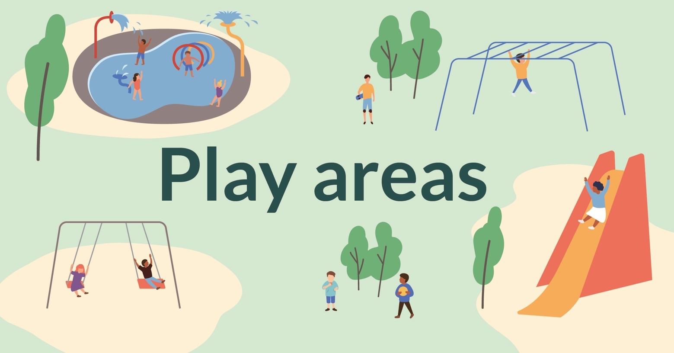

12: Do members of the group who look after children take them to use play areas in the parks? (Please note, these questions don't include adventure playgrounds in the borough).

Please tick one option only

❒ | ❒
Yes | No

If you answered "No" to question 12 then go to question 15

13: If so, which one(s) do they use

Please tick all that apply

❒ | Abbey Wood Park | ❒ | Altash Gardens
❒ | Avery Hill Park | ❒ | Bostall Gardens
❒ | Briset Park | ❒ | Charlotte Turner Gardens
❒ | Charlton Park | ❒ | Eaglesfield Park
❒ | East Greenwich Pleasaunce | ❒ | Eltham Park South
❒ | Fairy Hill Park | ❒ | Gallions Reach Playground
❒ | Garland Road Playground | ❒ | Horn Park
❒ | Hornfair Park | ❒ | Maryon Park
❒ | Plumstead Gardens | ❒ | Queenscroft Park
❒ | Southwood Road Park | ❒ | St Alfeges Park
❒ | Sunbury Street Playground | ❒ | Sutcliffe Park
❒ | The Course | ❒ | Villas Road Playground
❒ | Well Hall Pleasaunce | ❒ | Winn's Common
❒ | Other

13.1: If you answered ‘Other’ please specify which playground/s they visit

14: What do the children enjoy most

Please tick all that apply

❒ | ❒ | ❒ | ❒ | ❒
Swings | Slides | Climbing frames | Monkey bars | Other

14.1: If you answered ‘Other’ please specify what other equipment they enjoy playing with

15: If the borough's paddling pools were improved and/or converted to splash parks would they use them?

Please tick one option only

❒ | ❒
Yes | No

16: If there was one thing they would change about their local play area, what would it be?

Sport and fitness



17: How do group members use the park for sport/fitness?

Please tick all that apply

❒ | Sports courts | ❒ | Walking
❒ | Running | ❒ | Cycling
❒ | Tennis | ❒ | Bowls
❒ | Outdoor gym | ❒ | Team sports
❒ | Exercise with an instructor or trainer | ❒ | Skateboarding
❒ | Yoga | ❒ | Pilates
❒ | Other | ❒ | I don’t

18: Do they think there are enough sports facilities in the park/s they visit?

Please tick one option only

❒ | ❒ | ❒
Yes | No | I don't know

19: How could the parks sports facilities improve?

Please tick all that apply

❒ | More equipment | ❒ | Renovated equipment
❒ | Better path surfaces | ❒ | Better sports courts markings
❒ | Better running markers | ❒ | Other
❒ | Don’t know

19.1: If you answered ‘Other’ please specify how else they could improve

Heritage

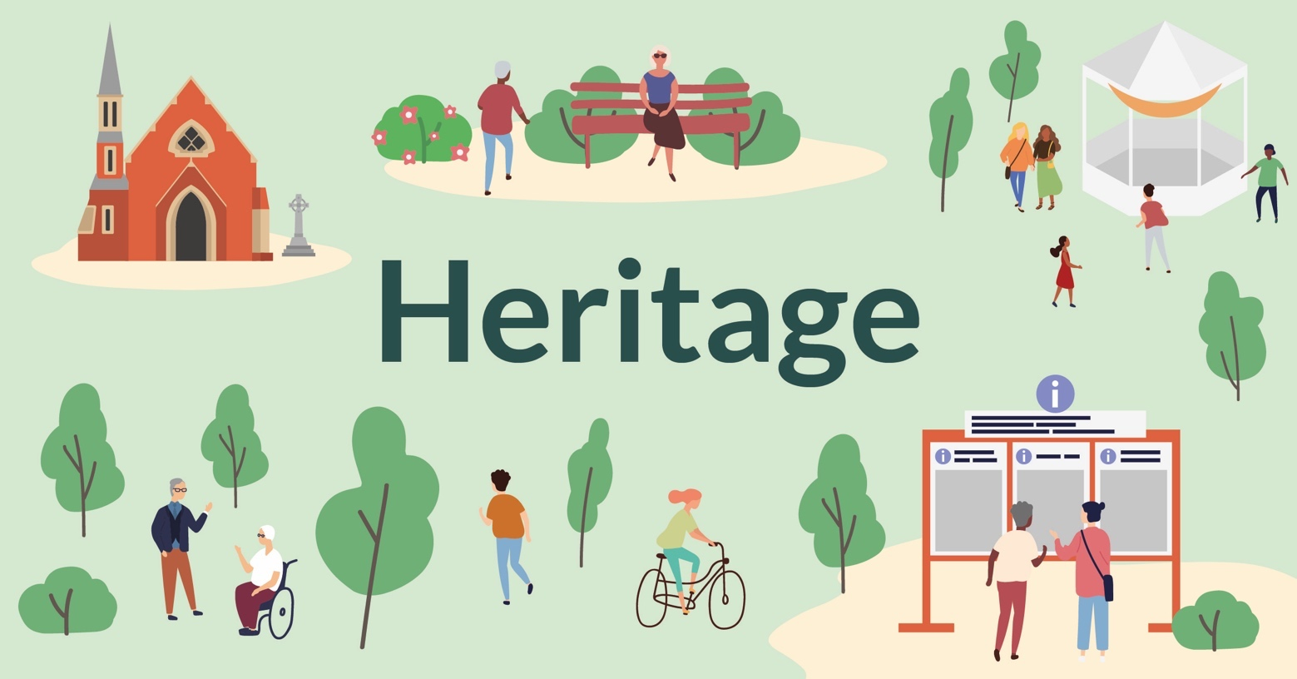

20: How important is preserving the history of parks?
1 Very important, 2 Important, 3 Neither important nor unimportant, 4 Unimportant, 5 Very unimportant

Please tick one option only

❒ | ❒ | ❒ | ❒ | ❒
1 | 2 | 3 | 4 | 5

21: Is there a particular heritage park or park feature that the group think needs protecting?

Please tick one option only

❒ | ❒ | ❒
Yes | No | I don't know

22: If yes, which one

23: If there were educational materials e.g. notice boards in your park, would group members stop to look at them?

Please tick either or both

❒ | ❒
Yes | No

24: Why have you answered yes or no?

25: Would group members want to be involved in potential projects to preserve the park's heritage? How many would and how many wouldn’t?

[page break]

Nature and wildlife

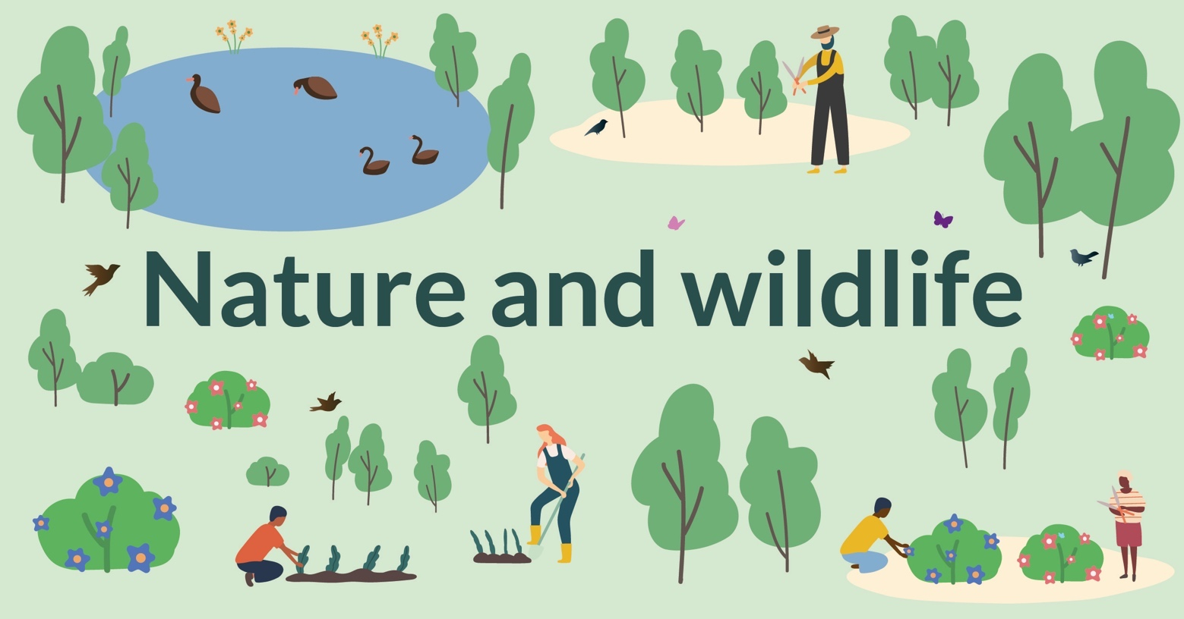

26: How happy would members be with having additional wild flower areas and wild grass in the park?

Please tick all that apply

❒ | ❒ | ❒
Very happy for any wild grass/wild flowers | Happy for there to be some patches of wild grass/wild flowers | Not happy with wild grass/wild flower areas

27: What kind of nature would members like to see in their park?

Please tick all that apply

❒ | New conservation grass areas | ❒ | Wildflower areas
❒ | Additional tree/hedge planting | ❒ | Pond restoration and conservation
❒ | New wildlife habitats created | ❒ | I wouldn't
❒ | I don't know

28: Are they aware of any nature projects running in your local park?

Please tick one option only

❒ | ❒
Yes | No

28.1: If you ticked “Yes” please specify

[page break]

Events



29: If group members have been to an event at a park, which ones have they been to?

Please tick all that apply

❒ | Parksfest event | ❒ | Music
❒ | Dance | ❒ | Fete
❒ | Circus | ❒ | Fundays
❒ | Market | ❒ | Other

29.1: If you answered ‘Other’ please specify which other events have they been to

[page break]

Basic facilities and maintenance

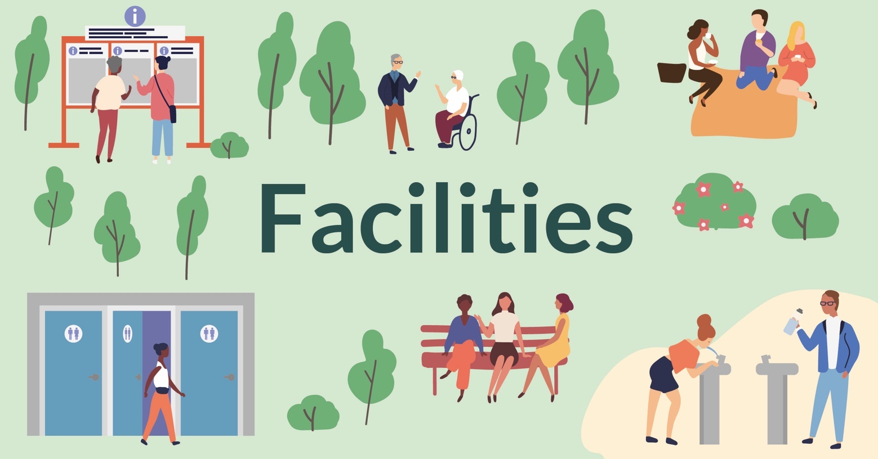

30: Which facilities do group members use most at their park:

Please tick all that apply

❒ | ❒ | ❒ | ❒ | ❒
Benches | Picnic areas | Toilets | Other | I don't know

30.1: If you answered ‘Other’ please specify which other facilities they use most

[page break]

31: How important are the following to the group
1 Very important, 2 Important, 3 Neither important nor unimportant, 4 Unimportant, 5 Very unimportant

Please tick one option only in each row

 | 1 | 2 | 3 | 4 | 5
Paths maintained | ❒ | ❒ | ❒ | ❒ | ❒
Entrances gates maintained | ❒ | ❒ | ❒ | ❒ | ❒
Railings and fences painted | ❒ | ❒ | ❒ | ❒ | ❒
More direction signs (and other signs) | ❒ | ❒ | ❒ | ❒ | ❒
Benches | ❒ | ❒ | ❒ | ❒ | ❒
Picnic areas maintained | ❒ | ❒ | ❒ | ❒ | ❒
Lighting | ❒ | ❒ | ❒ | ❒ | ❒
Feeling safe | ❒ | ❒ | ❒ | ❒ | ❒

32: How happy would you say the group members are with the condition of the facilities that they use?
1 Very happy, 2 Happy, 3 Neither happy nor unhappy, 4 Unhappy, 5 Very unhappy

Please tick one option only in each row

 | 1 | 2 | 3 | 4 | 5
Paths | ❒ | ❒ | ❒ | ❒ | ❒
Entrances gates | ❒ | ❒ | ❒ | ❒ | ❒
Railings and fences | ❒ | ❒ | ❒ | ❒ | ❒
Direction signs | ❒ | ❒ | ❒ | ❒ | ❒
Benches | ❒ | ❒ | ❒ | ❒ | ❒
Picnic area | ❒ | ❒ | ❒ | ❒ | ❒
Toilets | ❒ | ❒ | ❒ | ❒ | ❒

33: What park facility improvements would they like to see?

Friends of Parks groups


34: Would any of your members like to become a member of their local 'Friends of Parks' group?

Please tick one option only

❒ | ❒
Yes | No
❒
Already a member

If you answered "Yes" to question 34 then go to question 36, If you answered “No” please go to question 38, if anyone is already a member of a group please go to question 35

35. If any members are already a member of a friends of Parks group, please can you tick which ones they are a member of

Please tick one option only

❒ | Avery Hill Park | ❒ | Blackheath (including The Point)
❒ | Bostall Gardens | ❒ | Bostall Heath and Woods
❒ | Charlton Park | ❒ | Coldharbour Open Spaces
❒ | Eaglesfield Park | ❒ | East Greenwich Pleasance
❒ | Eltham Park North and South | ❒ | Horn Park
❒ | Kidbrooke Green Park | ❒ | Maryon Willson Park
❒ | Mycenae Gardens | ❒ | Oxleas Woods
❒ | Pet Cemetery (Hornfair Park) | ❒ | Plumstead Common
❒ | Queenscroft Park | ❒ | Rockliffe Gardens
❒ | Shrewsbury Park | ❒ | Sutcliffe Park
❒ | The Tarn | ❒ | Twinkle Park
❒ | Well Hall Pleasaunce | ❒ | Bostall Community Garden
❒ | St Alfege Park | ❒ | Southwood Park
❒ | Friends of Bostall Gardens

If you answered the question above (question 35) then go to question 38

36: If yes, please confirm the names of the parks and provide their name and contact details.

37: Please tick the following box to confirm that you agree that this information can be shared with the management committee of the local park friends group

Please tick one option only

❒ | ❒
Yes I agree | No I do not agree
38: Is there anything else you'd like to tell us about your experience of using the borough's parks or improvements you'd like to see.

Information about your group
39: Please give a brief overview of your group, including the name of the group, what support it provides and the average age and gender split of the group members

Please either email this back to parks@royalgreenwich.gov.uk or post it to: FAO C. Lambert.
The Oxleas Woods Centre, Crown Woods Lane, London SE18 3JA

