2020 - 2021 Annual Customer Service Satisfaction Survey

Summary of results received up to 31st March 2021

Greenwich Local Labour and Business (GLLaB) is the Royal Borough of Greenwich award winning local labour initiative - holder of both the Customer Service Excellence award and Matrix standard.

Our staff aim to provide an excellent customer service experience to service users through delivery across all our service provision. To measure how well we are performing against our Customer Service Standards, GLLaB uses an annual customer service satisfaction survey and Jobs and Skills Fair Survey. The 2020-2021 customer satisfaction survey collated responses over a twelve-month period from April 2020 to March 2021. This year our delivery has been significantly affected by the COVID 19 pandemic and we have adapted our survey questions to capture customer thoughts on the changes we have made to our service during this period and how they feel we have responded to the circumstance.

The Annual survey was given to a range of service user groups, including customers attending remote adviser appointments, online training courses and work clubs. We have also 154 customers completed the survey.

The overall customer service satisfaction rating given by service users:

93% Excellent or Good
Customer Comments:

We welcome all feedback from our service users to help identify what we do well and what we could be doing better. The following comments were supplied by service users
in their annual survey form.
Face to Face video calls have been really helpful through lockdown. I feel less isolated

The help, advice and support received from my adviser has been so helpful especially through COVID 19 period

The communication is always very helpful, I am aware of all web-based training and latest vacancies in the area. My Adviser helped me with applications by sharing screen
Staff are very helpful and all the courses I attended were very good

Always helpful, friendly and focus on wellbeing

Survey results

We have adapted and made changes to our service throughout the COVID 19 pandemic period and as such, adapted the GLLaB survey questions to collate accurate feedback from customers regarding the pandemic period. The questions have been designed to capture as much customer insight and responses to the service changes.

Due to the changes in questions, a year on year comparison is not for this analysis report. Please see below the results to the survey questions completed by 154 GLLaB customers. We will use these responses from customers to improve the service and work on implementing changes to improve scores for next year.

Aim: 85% of customers surveyed answer each question at either ‘Excellent or Good’ or ‘Always and Mostly’. 90% of customers to rate the Overall service received at ‘Excellent or Good’.

Table 1: GLLaB Customer Satisfaction Survey results

Inclusive and Accessible Service

 | Always or Mostly | Sometimes
Have you found the service easy to access and useful? | 80% | 20%
Do you feel staff are helpful and welcoming? | 93% | 7%
Do you feel you are treated with dignity and respect when you access the service? | 96% | 4%
Do you feel safe and secure in accessing GLLaB services remotely? | 91% | 9%
Engagement & Contact

How do you currently engage with GLLaB staff? | Of the tick box options available the below will include one person ticking multiple boxes per survey completion  Email only – 8%  Phone only – 10%  Phone and email – 22%  Phone, text, and email – 18%  Text and email – 4%  Video call only – 4%  Video call, phone and text – 4%  Video call, phone, text and email – 13%
 | Always or Mostly | Sometimes
If you call GLLaB, is your call answered? | 81% | 5%
If yes, were you contacted within two working days? | 75% | 5%
If you have left a message did you receive a call back / response? | 85% | 5%
Do you feel the information, advice, and guidance GLLAB provide is useful? | 80% | 20%
 | Excellent or Good | Satisfactory
Overall, how would you rate the training opportunities at GLLaB? | 93% | 7%
Overall, how would you rate the Job vacancies we have at GLLaB? | 74% | 20%
Overall, how would you rate the service you have received from GLLaB? | 93% | 7%
About the help you received from GLLaB, please rick all the boxes that apply to you | Of the tick box options available the below will include one person ticking multiple boxes per survey completion  Feeling less isolated – 55%  Improved health & wellbeing – 66%  Improved confidence – 75%  Improved job application skills – 71%  Improved job search skills – 81%  Improved cv – 79%  Improved interview skills – 44%  Accessed training – 78%  Secured work – 35%  Improved English language skills – 20%

Graph 1: Work & Health Programme Participant Satisfaction Survey results

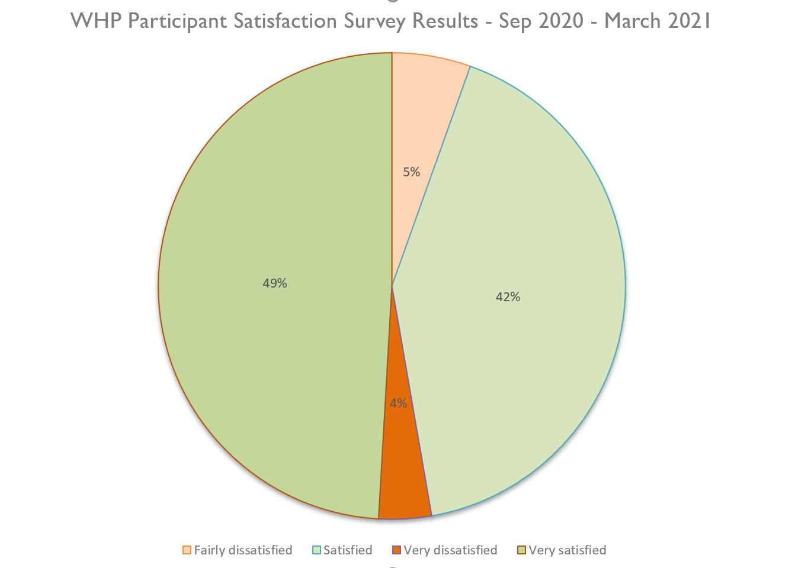

Areas of improvement identified:

Whilst ‘overall’ we are exceeding customer service satisfaction targets, where more than 5% of service users expressed that a particular service area was less than excellent e.g. scoring in the survey: ‘sometimes’, ‘rarely’ or ‘never’ – we have identified what we could do differently or improve on these areas.

1. Accessibility and ease of use

80% scored “Always or Mostly”

Throughout the COVID 19 pandemic period we continue to review and make improvements to drive up our performance in this area. It is a Council wide commitment to enable residents to be able to access GLLaB services through all mediums. All officers are well equipped and trained on keeping communication with customers remotely however the digital shift forced by the pandemic has been difficult for residents. Data and an appropriate device are needed to maximise use of GLLaB services such as bulletins, training courses and interaction with officers/ advisers. We are working with customers furthest away from the labour market and often this cohort do not have the means to access digital services. As a Council we are working on increasing the accessibility of residents through a range of funding schemes and initiatives such as laptop loaning schemes etc.

2. Engagement and contact

Avg. 80% scored “Always or Mostly”

Increasing our accessibility as a service is our priority. A mixture of methods is used to contact customers and from the survey results, the most popular methods have been phone and email throughout the pandemic period. The various teams within GLLaB are working on increasing video calls to simulate that of a face to face appointment. As lockdown restrictions ease, we are aiming to see as many people face to face as safely as possible but future working will involve more video calls as the general feedback has been that it promotes safety and security in terms of confidentiality. As officers continue to work from home there have been various issues with equipment such as phone lines and internet, this will affect engagement rates and call back rates. We aim to monitor this over the next year as we go into a more flexible way of working.

3. Job vacancy rating

75% scored “Excellent or Good”

At GLLaB we have seen a shift in the customer wants and needs since the start of the pandemic period. We have also implemented new programmes during this period that have been designed to support those made redundant as a result of working in a sector that has been “shutdown”. Traditionally GLLaB supports those a lot further away from the job market but we have now seen an increase of highly skilled professionals seeking the support on offer. The Job Brokerage team have had to adapt and have been liaising with employers in different sectors to cater to the diverse needs of the residents today. Although we want to achieve 85% satisfaction of all customers, we understand that we are in a difficult period in the labour market and will aim to respond accordingly.

4. Programme dissatisfaction

9% scored “Fairly or Very Dissatisfied”

Many services have been affected throughout the pandemic period regarding staffing. Work & Health programme participants have the option of working with a qualified health professional on the programme, it is one of the main features of the delivery model. We lost staff to the NHS who were in need of frontline workers throughout the pandemic period. Therefore, inconsistencies in staffing meant disruption to the customer journey for some participants. We now have a consistent compliment of staff who contact customers every 10 days on the programme.

Complaints

Both formal and informal complaints received into GLLaB are responded to in full within 10 working days. We provide an opportunity for service users who are not satisfied with the initial response to take their complaint further – to the GLLaB Manager, and beyond to the Ombudsman or Independent Case Examiner.

We follow up with customers who have had cause to report dissatisfaction with our service, to rectify the issue to the best of our ability and to the satisfaction of the customer wherever possible.

