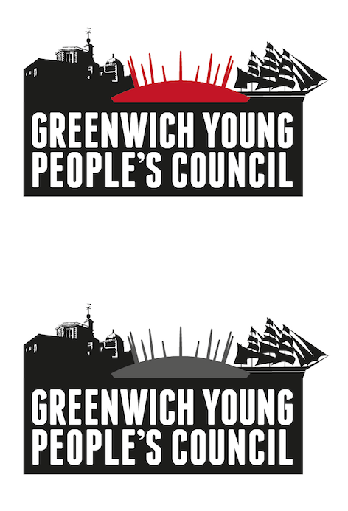

Greenwich Young People’s Council Elections 2022   
The Ultimate Guide for Nominees

Hello!

**Thank you for your interest with the 2022 Greenwich Young People’s Council (GYPC) Elections.**

This guide explains a few things to help you get involved in the GYPC elections! Please take some time to read through this document in its entirety and get in touch with any questions you may have !

Greenwich Young People’s Council team.

# Greenwich Young People’s Council

**Who are Greenwich Young People’s Council?**

Greenwich Young People's Council (GYPC) is a group of elected young people, which exists to represent the views of children and young people from across the borough and to influence decision-making within the council.

GYPC representatives are age 11 to 18 and up to age 25 for disabled young people.

Youth councillors are elected from schools and colleges in Greenwich, and include representatives from the Children in Care Council, Greenwich's youth service and representatives of young people with special educational needs and disabilities.

**What do GYPC get up to?**

GYPC gets up to a lot of different activities. Everything we do is to raise awareness of and promote the meaningful engagement of young people in politics, democracy and citizenship. We do this by:

* Producing an annual manifesto and action plan, which focuses on the key issues that affect the lives of young people in Greenwich.
* Running campaigns on our annual manifesto priorities.
* Holding events throughout the year for young people across the borough, in partnership with the Children in Care Council and other youth groups.
* Running consultations with young people on issues in our manifesto.
* Advising on policies, activities and services that affect young people in Greenwich.
* Requesting meetings and reports from the council and organisations in Greenwich on issues identified by GYPC in their annual manifesto.
* Facilitating relationships between young people and organisations that represent or provide services for young people.

One of GYPC’s key aims is to break the negative stereotypes held by society of young people, by having a positive impact on young people and communities.

**What is expected of a Youth Councillor?**

Youth Councillors are asked to commit around 2-4 hours per week, which includes:

* Attending weekly GYPC meetings, representing young people.
* Actively contributing to and leading campaigns and events.
* Taking part in additional opportunities, such as interview panels or consultations.
* The completion of national accreditation.
* Checking and responding to emails, texts or messages.

**There is also an opportunity to become a Member of Youth Parliament (MYP).**

The candidates with the most votes across Greenwich will be offered the role of MYP. MYP's represent GYPC nationally, and have additional responsibilities to youth councillors. The running up two candidates will be offered the roles of Deputy Members of Youth Parliament and others elected will become youth councillors. More information will be provided at the candidate training day.

Youth Councillors are also required to follow the GYPC Constitution and Code of Conduct. This is publicly available on the GYPC webpages on the Royal Greenwich Council website.

# Your involvement

We are excited that you want to be involved in the 2022-2023 Greenwich Young People’’s Council elections!

**1. Overview of the whole election process:**



# The Process Explained:

**A. Nomination Process**

You will be required to **complete a nomination** **form**, which will include your manifesto and a skills analysis. In addition, you must collect a minimum of 25 signatures of young people who support your nomination.

All nomination information will be made available on the Royal Greenwich website AND will be emailed directly to your school/ group. The nomination period will be **Monday 12 September - Friday 18 November (5pm).**

**B. Candidate Training Day**

If you are a successful candidate, you will be required to attend a full-day (10am-4pm) training session. This is mandatory and you can choose to come on either **Saturday 3rd December OR Saturday 10th December.** This training day will gives you a chance to:

* Learn communication and campaigning skills;
* Learn how to campaign through social media;
* Learn about safe, appropriate but powerful campaigning; and,
* Plan their campaign strategy.

**C. Candidate Campaigning Period**

You will have 3 weeks to campaign for votes in your school/college/group from **Monday 3 January - Friday 20 January.** Youth Voice Service staff will be on hand for support and advice to both candidates and community groups so please do not hesitate to get in touch. We will also broadcast daily campaign tips to candidates via text and social media.

**D. Voting**

Voting takes place across five days: **Monday 23 January - Friday 27 January.**

**F. Ballot Count**

Ballot boxes will be stored securely until the ballot count, which will take place week commencing **Monday 30th January.**

**G. Results Declaration**

The GYPC election results will be announced formally on **Thursday** **2 February.**

# Key Dates

| **Date** | **Event** |
| --- | --- |
| Monday 12 September | **GYPC Elections Launch** / Nominations Open |
| Monday 12 September – Friday 18 November | **Nomination Period (10 weeks for max. reach)**  - inc. assemblies & promotion in schools  - plus, manifesto ‘drop-in’ sessions for support. |
| Friday 18 November, 5pm | **Nominations Close** |
| Monday 21 – Friday 25 November | **Nominations Wash Up & Processing** |
| Saturday 3 December OR Saturday 10 December | **Candidate Training Days** (Candidates only attend 1) |
| Monday 12 December – Monday 2 January 2023 | **Christmas Holiday Break** |
| Tuesday 3 January – Friday 20 January | **Candidate Campaigning Period (3 weeks)** |
| *By* Friday 20 January | **Ballot Boxes Arrive at Centres** |
| Monday 23 January – Friday 27 January | **Voting Period** |
| Monday 30 January | **Ballot boxes collected** & stored securely |
| W/C Monday 30 January (TBC) | **Ballot Count** (Town Hall, TBC) |
| Thursday 2 February | **Results Event (Town Hall, TBC)** |
| Throughout February | **GYPC Induction Meetings** |
| Wednesday 1 March 2023 | **New Youth Councillors Start** |

# Why get involved?

Getting involved in the GYPC elections has numerous benefits:

**Benefits for young people**

Young people who are elected as Youth Councillors and Members of Youth Parliament get a LOT from the experience:

* Lots of fun!
* The opportunity to have your voice heard AND make positive changes for young people
* The chance to represent other young people in your community.
* Meet new people across Greenwich, London and the UK.
* The chance to get to know Greenwich better.
* Opportunities to gain accreditations.
* Receiving free training, coaching and mentoring.
* A reference for school, college, university or employment.
* Trips and residential opportunities in and out of the borough!

**AND**, the elections experience is rewarding for every candidate:

* Learning new skills.
* Meeting new people across Greenwich
* Experience democracy first hand.
* Considering what would make Greenwich even BETTER for young people.

# Key Contacts

If you have questions, queries or concerns, please get in touch with Greenwich Young People’s Council team:

**Email:** [greenwich@participationpeople.com](mailto:greenwich@participationpeople.com)

**Phone:** Ella Green (Youth Voice and Influence Officer) 07841015716

**Twitter and Instagram:** @GreenwichYPC

*The Participation People are commissioned to deliver Greenwich Young People’s Council on behalf of the Royal Borough of Greenwich*