

**Winter 2023 Bid**

The Royal Greenwich Together, Holiday Food and Fun Winter 2023 programme will run from 22nd December 2023 to 5th January 2024 ***(please note that 25th*** ***December, 26th December and 1st January are bank holidays).*** We are looking for a range of different schemes with the aim to provide as many spaces as possible for children and young people in Greenwich to attend Holiday Food and Fun during the winter school holidays.

To apply for a grant, please complete the following bid process:

1. Read through the bid questions carefully and the scoring guidance on this form before you write your answers.
2. Do not leave any sections or boxes blank. Please provide sufficient information to provide complete answers to be marked against the scoring guidance.
3. If you wish to run more than one programme (different locations), or more than one session per day (same location) or more than one category, please complete one form **PER** session.
4. If you have any questions about the bid, please get in touch with RBG HAF Team at [holiday-programme@royalgreenwich.gov.uk](mailto:holiday-programme@royalgreenwich.gov.uk)
5. Submit your completed Winter 2023 bid to [holiday-programme@royalgreenwich.gov.uk](mailto:holiday-programme@royalgreenwich.gov.uk) no later than **Friday 15th September, 5pm**.
6. You will receive a confirmation e-mail once your application is received.
7. Any bids submitted after the closing time will **not** be considered for this call out period.
8. You may be contacted for clarification questions.

**Please complete the following sections:**

1. **Organisation information and Programme details**

* Ideally, your venue will be in an area of high deprivation. Please see the Greenwich Levels of Deprivation FSM heat map on page 9 showing which areas of the borough have the highest levels FSM.
* The number of children and young people (CYP) per session is how many spaces you have available per day. This number should be realistic and reflective of your previous experience with provision for children and young people.
* **If you wish to run more than 1 programme (different locations), or more than 1 session per day (same location) please complete one form PER session.**

|  |  |
| --- | --- |
| **Organisation:** |  |
| **Key contact name:** |  |
| **Key contact e-mail:** |  |
| **Key contact phone:** |  |

**Programme details**

|  |  |
| --- | --- |
| **A1. Location of the programme: (If you do not have a secured venue, please indicate your plans to secure one)** | **Address:** |
| **A2. Ward of your programme:** |  |
| **A3. Which dates do you wish to deliver your HAF programme: (between 22nd December – 5th January)** |  |
| **A4. Total number of days:** |  |
| **A5. Number of hours per session:** |  |
| **A6. Generic Provision: number of spaces per session:** |  |
| **A7. SEND Provision: Number of spaces for CYP with additional support: (only if you are an approved category 2 or 3 provider)** |  |
| **A8. Total number of spaces per session:** |  |
| **A9. Total number of staff per session:** |  |
| **A10. Age range of CYP who can attend:** |  |

1. **Proposed activities**

Please provide information about the activities that you wish to provide to CYP and their families. The activities should be in line with the mandatory DfE requirements for HAF. Refer to section five of the Guidance Notes and Service Specification for details on the mandatory requirements. Higher scores will be awarded where programmes have clear, structured activities, examples of previous experience, and where applicants maximise their resources, partnerships and expertise to benefit the CYP attending their programme.

**If you plan to take CYP on any trips or excursions, please ensure they are outlined in the questions below, where appropriate.**

Please follow the guidance of the word limit and provide detailed answers. Each question in this section will be scored on a scale of 0-5.

*B1. Please provide a description/summary of what your programme would generally deliver and who would benefit. How would you explain your programme to a child/ young person or a parent? What makes your programme unique? (Min 100 words – max 150 words)*

|  |
| --- |
|  |

*B2. The programme requires a minimum of one hour of structured physical activity to be provided during every session. Please tell us how you will achieve this and give examples of how all CYP would engage in physical activity at your programme. (Min 100 words – max 200 words)*

|  |
| --- |
|  |

*B3. The programme requires food skills or nutrition activities to be provided at every session. Please tell us how you will achieve this and give examples of how CYP would increase their nutrition knowledge at your programme. (Min 100 words – max 200 words)*

|  |
| --- |
|  |

*B4. Please set out how you will deliver enrichment activities that support the skills development of CYP specifically for the age groups you are applying to deliver to, including examples. (Min 100 words - max 200 words)*

|  |
| --- |
|  |

**C: Food offer**

Please provide detailed descriptions to the following questions about how you will manage the provision of food and snacks at your sessions. Please refer to section 5.2 of the supporting information document for more information about the mandatory food requirements of the programme.

Questions 1 through 4 will be scored on scale of 0-5. Question 5 is worth 1 point.

|  |  |
| --- | --- |
| 1. **Please explain how you will source and prepare the food / meals to be provided for the programme. If using an external caterer, please give their details. Min 75 words - Max 150 words.** | |
|  | |
| 1. **Please explain how you will ensure all food is served safely at your programme. Min 75 words - Max 150 words.** | |
|  | |
| 1. **Please explain how you will ensure your menu and all food served meets the School Food Standards. Min 75 words - Max 150 words.** | |
|  | |
| 1. **Please explain how you will manage dietary requirements, allergies and cultural needs. Min 75 words - Max 150 words.** | |
|  | |
| **5a. Estimated cost per meal** | £ |
| **5b. Estimated cost per snack** | £ |
| **5c. Estimated Total cost of food provision (all meals & snacks) for the whole programme:** | £ |

**D: Quality Assurance**

Each question in this section will be scored on a scale of 0-5.

*D1. Please describe your plans to recruit children and young people in Greenwich who are in receipt of (or eligible for) benefit-related Free School Meals to your programme? This should include how you will check eligibility, how will you manage, and maximise attendance of your programme, proposed outreach activity as well as your plans and experience of working with schools to maximise recruitment and FSM eligibility, including which schools. (Min 250– max 400 words)*

|  |
| --- |
|  |

*D2. Explain how you will identify, record and report safeguarding issues? How will you ensure that safeguarding processes are current and in line with RBG policies and procedures? How will you ensure all staff (paid and unpaid) are trained / confident in this area of work. (Min 300 – max 400 words).* ***Note – failure to score a minimum of 3 out of 5 on this question will result in exclusion from consideration for funding.***

|  |
| --- |
|  |

*D3. Explain how your organisation handles complaints? How do you know that your staff (paid and unpaid) are aware of how to manage complaints? This should include clear timescales for acknowledgement and investigation of complaints and how as an organisation you will learn from them. Min 300 – max 400 words.* ***Note – failure to score a minimum of 3 out of 5 on this question will result in exclusion from consideration for funding.***

|  |
| --- |
|  |

*D4. Please tell us how you evaluate the quality and success of your programme? This should include examples of lessons learned from previous delivery and how you use feedback, specifically from children, young people, and parents to inform service development. Min 300 – max 400 words.*

|  |
| --- |
|  |

*D5. Please tell us how you will ensure that families are aware of relevant local services in Greenwich. This should include examples of how you have successfully signposted or referred a family / CYP and what the outcome was. Min 200 – max 400 words.*

|  |
| --- |
|  |

**E: Budget and Programme cost**

Please provide an estimated / approximate breakdown of the costs to run your programme

Evaluators will be looking at best use of resources and how you maximise the impact on the CYP attending your programme. You may add additional items as needed for your programme. There may also be items that have no cost for you but still do list them.

With staffing, we require details on the number of staff, their role and how much they are paid. Also as outlined in the supporting guidance, staff must be paid London Living Wage.

Please note that the prices outlined in Table 5 of the Guidance Notes are the maximum prices we will pay for services, therefore, **value for money will be considered by evaluators**. If costs exceed this amount, bids will not be considered.

This question will be scored on a scale of 0-5.

|  |  |  |
| --- | --- | --- |
| **Item** | **Description** | **Cost** |
| Venue |  | £ |
| Staffing | *Include number of staff, roles, and wages* | £ |
| Management | *Provide detailed breakdown of management costs* | £ |
| Equipment hire |  | £ |
| Trips / excursions |  | £ |
| Transport |  | £ |
| Total Food cost |  | £ |
| Other (please provide breakdown) |  | £ |
| **Total programme cost** | | £ |
| **Cost per child, per hour (Generic Provision)** | | £ |
| **Cost per child, per hour (Specialist SEND Provision)**  **(Only if applying for category 2 or 3)** | | £ |

**Application form completed by:**

|  |  |
| --- | --- |
| **Name** |  |
| **Role within organisation** |  |
| **Date** |  |

**Appendix 1: Greenwich level of households on FSM**

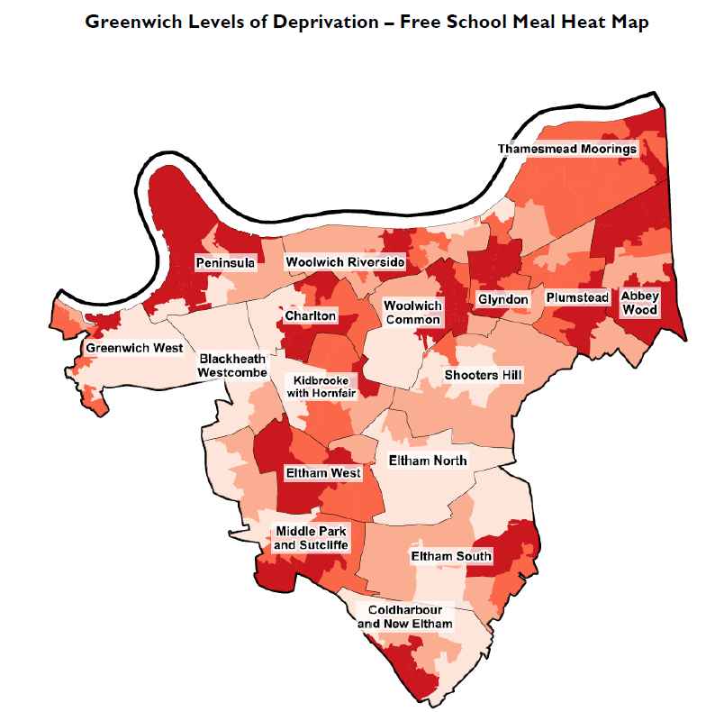

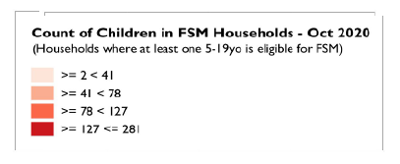

**Appendix 2: Scoring Guidance for Winter 2023 Bids**

|  |  |  |
| --- | --- | --- |
| **Score** | **Acceptability** | **Participant response demonstrates** |
| 0 | **No Response**  (Unacceptable) | * No response received * The response does not address the questions posed |
| 1 | **Weak**  (Serious Reservations) | A response which is unacceptable or contains shortcomings; e.g. shows very poor understanding of the Council’s objectives, provides insufficient or contradictory evidence for evaluation, does not address the stated requirements. Has insufficient evidence that the specified requirements can be met. Significant omissions. |
| 2 | **Poor**  (Minor Reservations) | A response which shows some understanding of the requirements but does not address key issues; e.g. proposals do not address all key criteria, shows only a basic understanding of the project requirements, evidence is vague, not enough evidence of experience in the relevant sector. Submission has some minor omissions against the specified requirements. Proposal achieves basic minimum standard in some respects but unsatisfactory in others. |
| 3 | **Acceptable**  (Meets expectations) | The information is wholly acceptable, and the information provided fulfils the normal requirement/expectation; e.g. proposals demonstrate clear understanding of the Council’s requirements, clear evidence of understanding and the proposal is acceptable. |
| 4 | **Good**  (Above Expectations) | The information exceeds normal expectations. The proposal submitted provides good evidence that the specified requirements can be met. Full and robust responses. |
| 5 | **Excellent** (Outstanding) | The information is exceptional or exemplary in relation to the Criterion being scored; e.g. proposals consistently going beyond the needs of the project, evidence of understanding clear and consistent throughout the proposal. Proposal submitted provides strong evidence that the specified requirements can be met. Added value is demonstrated. |

**Appendix 3: Possible scores for questions on Winter 2023 bids**

|  |  |
| --- | --- |
| **Section and Question** | **Possible Score** |
| Organisation and contact info | 0 |
| A1. Location  A2. Ward of your programme | 1 |
| A3. Dates of programme | 0 |
| A4. Total number of days  A5. Number of hours per session | 1 |
| A6 Generic Provision: Number of spaces per session  A7 SEND Provision: number of spaces per session | 1 |
| A8. Total number of spaces per session | 0 |
| A9. Number of staff per session | 1 |
| A10. Age range of CYP | 0 |
| B1. General Description of programme | 5 |
| B2. Physical Activities | 5 |
| B3. Nutrition education and activities | 5 |
| B4. Enrichment activities and skills development | 5 |
| C1. How food & meals will be sourced? | 5 |
| C2. How food will be served safely? | 5 |
| C3. How will the menu and food served meet the School Food Standards? | 5 |
| C4. How will you manage allergies, dietary requirements and cultural needs? | 5 |
| C5. Cost of food | 1 |
| D1. Recruitment plans | 5 |
| D2. Safeguarding: ***Note – failure to score a minimum of 3 out of 5 on this question will result in exclusion from consideration for funding.*** | 5 |
| D3. Complaints: ***Note – failure to score a minimum of 3 out of 5 on this question will result in exclusion from consideration for funding.*** | 5 |
| D4. Evaluation and feedback | 5 |
| D5. Signposting and referrals | 5 |
| E. Budget | 5 |
| **Total possible score** | 75 |