Royal Borough Greenwich
Terms of Reference Combating Drugs Partnership

v1 Draft | Circulated at RBG CDP Meeting on 10/01/2024 | 10/01/2024
v2 Final | AGREED | 24/01/2024
 | To be reviewed | 24/01/2025

- BACKGROUND

These Terms of Reference (ToR) are developed to support the operation of the Royal Borough Greenwich Combating Drugs Partnership Board (CDP). The ToR sets out the key principles for the Board including governance and reporting arrangements, membership, roles and responsibilities, the aims and objectives of the group and meeting frequency.

The Greenwich CDP Board is a single, joined-up strategic forum and decision-making body developed to support the delivery of the National 10-year drug strategy ‘From Harm to Hope’ December 2021. The strategy recognises that a whole-system approach is required to focus on addressing the root causes of substance use rather than treating the symptoms in isolation.

To support delivery of the Strategy, the CDP is required to bring together a range of local partners including enforcement, treatment, recovery and prevention to understand and address shared challenges related to drug related harm by taking coordinated action. The Partnership is required to work collaboratively with National and local partners focusing on three strategic priorities to cut crime and save lives, that is to:

- Break drug supply chains
- Deliver a world-class treatment and recovery system
- Achieve a shift in the demand for drugs.
The National Combating Drugs Outcomes Framework provides a single mechanism for monitoring progress across central government and in local areas and sets out the commitment and ambition required to deliver the 10-year strategy. There are six overarching outcomes that successful delivery of the drugs strategy will achieve that is; to reduce drug-related crime, to reduce harm, reduce overall use, reduce supply, and to increase engagement in treatment and improve long-term recovery. There are also a number of supporting Metrics which are set out below and also at appendix (i).
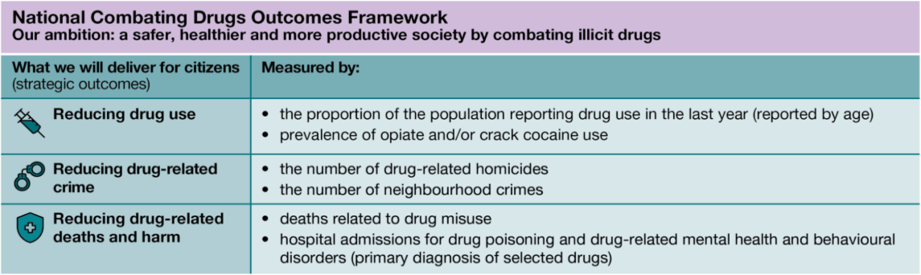
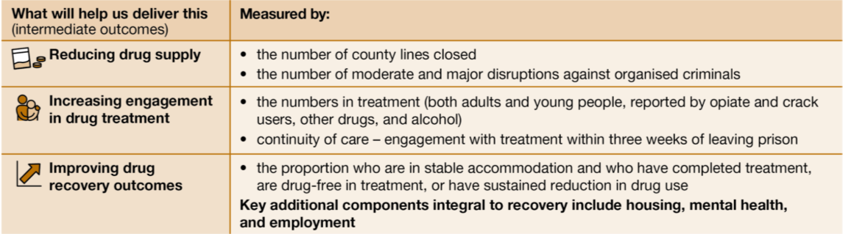

- AIMS AND OBJECTIVES

The Greenwich CDP Board will bring key partners together to strengthen and formalise existing partnerships/processes to ensure there is clear strategic direction and delivery of the governments drug strategy. The Board will work collaboratively with partners across RB Greenwich, provide accountability, scrutiny and oversight and will be responsible for

- Overseeing the development of a needs assessment and action plan in response to the Joint Combating Drugs Unit (JCDU) National Outcomes Framework.
- Overseeing delivery of the combating drugs plan including monitoring progress against all agreed performance indicators and agree actions to mitigate against performance that is not in line with the local CDP action plan.
- Commissioning and de-commissioning sub-groups or task and finish groups, holding them accountable for progress and request reports as appropriate.
- Managing barriers and issues affecting delivery of the local CDP action plan.
- Identify gaps in partners’ plans and make proposals to address them.
- Sharing local learning, log and monitor progress on agreed actions.
- Ensuring that effective processes are in place for listening and capturing input from all members and interfacing with relevant bodies.
- Ensuring that diversity, inclusion and the voice of people with Lived Experience is captured in the local CDP action plan.
- Providing a partnership level response to key issues and strategic challenges.
- Ensuring that Information Sharing Protocols are followed and all information sharing requirements are met.
- Ensuring progress reports from the partnership (and any sub-groups) are available to the SRO ahead of reporting scheduled for JCDU.
- Ensuring that the Safeguarding Executive Partnership Group, and other strategic partnerships which support delivery of Combating Drugs Partnership outcomes receive timely and relevant reports and information.
- Escalating issues which may be barriers to delivery and achieving outcomes.
- Providing visibility and accountability to each other and Greenwich residents.
- Ensuring that where relevant, the work of the CDP aligns with the Royal Borough Greenwich Borough Plan and strategies which impact people with Drug and/or Alcohol misuse.

- GOVERNANCE

3.1 The Greenwich CDP meetings will be chaired by the Director of Public Health as the Senior Responsible Officer (SRO). The meeting is not a public meeting and will be administrated by members of the RB Greenwich Public Health team. The Greenwich CDP will report to the Safeguarding Executive Partnership Group with a line into Strategic Partnership Boards.

Greenwich CDP Governance

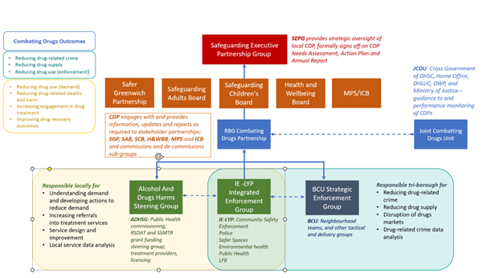

- Safeguarding Executive Partnership Group provides strategic oversight of the Greenwich Combating Drugs Partnership, and agrees the local needs assessment, action plan and annual report.

- Strategic Partnership Boards and strategic partners are all represented on the Safeguarding Executive Partnership Group. The Greenwich CDP will engage with or provide updates to these boards where it adds value, to consider specific outcomes and actions of the CDP. There is Cabinet level representation on a number of these boards.

- Elected member oversight is through annual reporting to the Safer Greenwich Partnership (and its Executive Group) and the Health and Wellbeing Board. The Cabinet Member for Health and Adults Services is the lead member for combatting drugs, supported by the Director of Public Health as SRO.

- Sub Groups - The Alcohol and Hidden Harms Steering Group, IE-Love Your Place (IE-LYP) Integrated Enforcement Group and the BCU Strategic Enforcement Group are Sub-Groups of the CDP and responsible for understanding and developing actions to reduce demand; increasing referrals into treatment; service design and improvement as well as local data and analysis.

The BCU is a tri borough initiative responsible for reducing drug related crime, reducing drug supply, disruption of the drugs market and drug related crime analysis.

4. MEMBERSHIP, ROLES AND RESPONSIBILITES
4.1 Membership

The Greenwich CDP brings together key strategic and operational members in line with guidance from the cross-Government Joint Combating Drugs Partnership. Members include senior representatives who may have a strategic or operational responsibility from Public Health, Safer Communities, Police, NHS, Office for Health Improvement and Disparities (OHID), Drug and Alcohol treatment services, as well as lived experience recovery organisations (LEROs).

The Senior Responsible Officer (SRO) for the Greenwich Combating Drugs partnership is the Steve Whiteman, Director of Public Health. There is a core membership and a wider reference group for circulation and invitees for specific themed discussions/focus.

Job Title | Organisation
Chair
Director of Public Health (SRO) | Royal Greenwich
Secretariat and Partnership Lead
Senior Public Health Manager | Royal Greenwich
CDP Executive Group (Proposed)
Head of Public Health Programmes | RB Greenwich
Designated Nurse for Adult Safeguarding | NHS South East London ICS (Greenwich)
Designated Nurse Safeguarding C&YP | NHS South East London ICS (Greenwich)
Service Leader, Youth Justice Service | RB Greenwich
Head of Operational Function, Bexley and Greenwich Probation Delivery Unit (PDU) | Probation Service London
Superintendent | Metropolitan Police Greenwich Neighbourhood Policing Team
Head of Safeguarding Vulnerable Adults, Health and Adult Services | RB Greenwich (links to SAB)
Young People's Substance Misuse Team Leader | RB Greenwich
Service Manager (Adults) | V-I-A Greenwich
Programme Manager (London Alcohol, Drugs and Tobacco) | Office for Health Improvement and Disparities (OHID)
Head of Safer Communities and Partnership, Safer Communities | RB Greenwich
Senior Community Safety Specialist Head of Integrated Enforcement and Safer Spaces | RB Greenwich
Manager | WSUP (Woolwich Service User Project)
Director of Health, Youth and Inclusion | Charlton Athletic Community Trust
Lead Worker | Thamesreach (Greenwich)
Partnership Manager, Greenwich | Department of Work and Pensions
Shelter Director | Greenwich Winter Night Shelter
Parental Substance Misuse Co-Ordinator | RB Greenwich
Lead Nurse COMHAD | Oxleas NHS Foundation Trust
Detective Chief Inspector, Project ADDER Programme | Metropolitan Police Service
Chief Operating Officer | NHS South East London ICS (Greenwich)
Assistant Director of Housing Needs and Tenancy, Housing and Safer Communities | RB Greenwich
Borough Commander | London Fire Brigade (Greenwich)

All attendees must be of appropriate seniority to have strategic oversight of their area of business. If the nominated post is unable to attend, then they must plan for a colleague to attend in their place who can represent their team/organisation.
- Roles and Responsibilities
Position | Responsibility
Chair | - Convene and chair partnership meetings  - Encourage full involvement of local leaders and putting in place the governance structure and culture to drive joint, system-wide decision-making  - Oversee the development and delivery of a shared local plan with a whole-system approach addressing the three strategic priorities set out in the drugs strategy  - Unblock issues across the system  - Report on the partnership’s performance and delivery into central government including sign off of RB Greenwich Supplementary Substance Misuse Treatment Grant plans and any other relevant plans as appropriate to this CDP work.
Secretariat | - Draft Agenda  - Arrange Meetings  - Note take agreed actions  - Coordinate and chase up actions  - Circulate documents and maintain records  - Coordinate quarterly reporting for meetings  - Support the Chair in representing the group when requested and  - Provide quarterly highlight reports
All Members | - Regularly attend and participate in meetings.  - Contribute their skills, knowledge and expertise.  - Align and coordinate the work of their organisation.  - Report and feedback to their organisation to share knowledge  - Identify gaps in knowledge of staff so they can participate in any training/upskilling opportunities that is commissioned as part of the CDP delivery plan  - Facilitate the sharing of relevant Data and Intelligence held by each organisation  - Agree as a partner the relevant local datasets and intelligence for the above purpose  - Provide feedback and/or contribute to any local plans when required to support the Chair fulfil their responsibilities as SRO  - Ensure the safe and secure sharing of data and intelligence within the partnership that is compliant with GDPR  - Identify and take responsibility to deliver the actions that are relevant to their organisation  - Take on the role of change agent to remove barriers and facilitate change  - Champion the Combating Drugs Partnership as a forum for change.
5. MEETING FREQUENCY
The Greenwich CDP will meet quarterly, with the frequency of sub-groups to be determined. Meetings will a combination of face to face, hybrid or online, as determined by members of the CDP. The duration of the meeting will be 1.5 hours. The meeting will be chaired by the Director of Public Health as the SRO. In their absence, the meeting will be co-chaired by the Assistant Director of Public Health.

Proposed meeting dates for 2024:
Wednesday 10th January 2024, 2:00pm - 3:30pm
Tuesday 23rd April 2024, 2:00pm - 3:30pm
Tuesday 11th June 2024, 2:00pm - 3:30pm
Thursday 3rd October 2024, 10:00am – 11:30am

- ATTENDANCE AND ADMINISTRATION
The CDP will be administered by RB Greenwich Public Health team as part of discharging the SRO responsibilities. Agendas and supporting papers will be circulated at least a week in advance of meetings, in consultation with the SRO. Members of the Combating Drugs Partnership can request agenda items through the SRO, at least two weeks prior to the meetings.
Notes and actions from the meeting will be circulated within a week of the quarterly meetings, and RB Greenwich Public Health will maintain an action log and ensure timely reporting to the Safeguarding Executive Partnership Group, and Health and Wellbeing Board, Safer Greenwich Partnership and JCDU.

To be quorate at least 50% of member organisations of the Partnership must be present.

Under exceptional circumstances, urgent decisions may be taken outside quarterly CDP meetings. The CDP Executive Group will be required to respond to and/or contribute to any external decision-making process.

- INFORMATION SHARING
Information sharing is crucial to the success and member organisations must commit to sharing key relevant data and information giving due regard to the appropriate data protection and information governance arrangements for the purpose of supporting the Greenwich CDP working arrangements.
- REVIEW
The CDP will review terms of reference and membership annually.
Needs Assessment and Delivery Plan to be reviewed every three years. However, risks and challenges for any emerging and immediate needs to be considered by the partnership.

Appendix (1) Additional Metrics
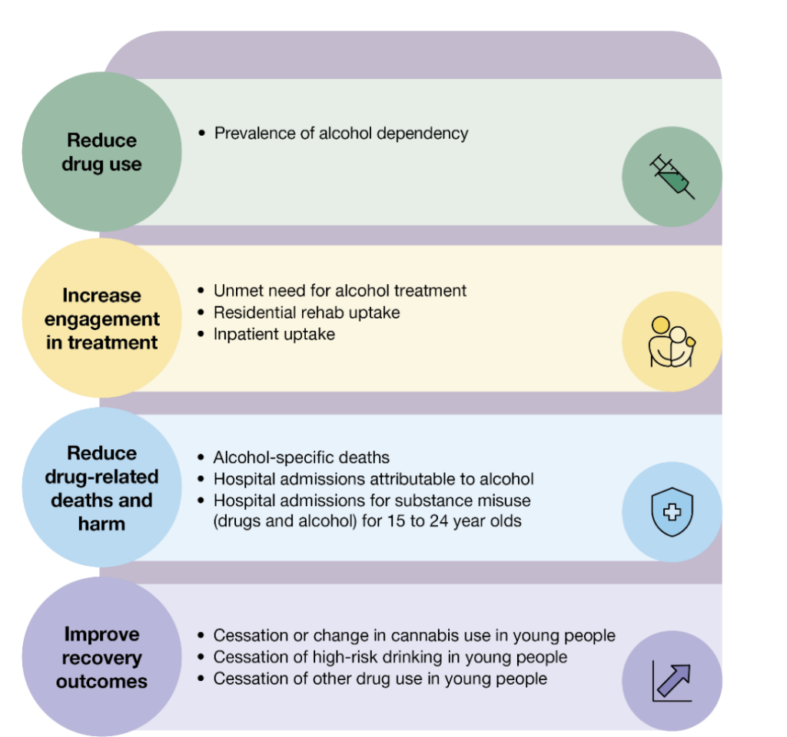
Appendix (ii) Local Needs Analysis development
